**GG/1920s Speakeasy 2017**

**Choose your historical celebrity:** You will get to choose, however the order of who chooses will be randomly determined and we will have only 10 characters doubled up. That means you should be prepared with a couple choices.

**Politics**

Warren G. Harding

Herbert Hoover

Calvin Coolidge

Williams Jennings Bryant

Eugene V. Debs

Marcus Garvey

W.E.B. Du Bois

A. Mitchell Palmer

Albert B. Fall

Clarence Darrow

**Outlaws**

Roy Olmstead

Nicola Sacco (accused)

Al Capone

Bartolomeo Vanzetti (accused)

**Feminist Movement**

Margaret Sanger

Alice Paul

Charlotte Perkins Gilman

**Business/Entertainment**

Walt Disney

Groucho Marx

Charlie Chaplin

Bill Robinson

Bruce Barton

David Sarnoff

Henry Ford

Greta Garbo

**Sports**

Jack Dempsey

Babe Ruth

Gertrude Ederle

Jim Thorpe

Charles Lindberg

Amelia Earhart

**Literature/Music/Arts**

Louis Armstrong

Bessie Smith

Norman Rockwell

Ernest Hemmingway

F. Scott Fitzgerald

Zora Neale Hurston

Langston Hughes

Duke Ellington

Aaron Douglas

Jacob Lawrence

Georgie O’Keefe

Zelda Fitzgerald

**Gatsby Characters**

Jay Gatsby

Nick Carraway

Daisy Buchanan

Tom Buchanan

Jordan Baker

Myrtle Wilson

**GG - 1920s Slang**

**Get ready to “know your onions.”** If you ever wanted to talk like characters from an old movie or the folks from *The Great Gatsby*, now’s your chance. For the twenties lovers among us, here are some of the era’s best slang phrases. Try using them in conversation. What’s old is new again!

 A

**ab-so-lute-ly:** affirmative, yes

**air tight:** very attractive

**Airedale:** an unattractive man

**alarm clock:** a chaperone

**And how!:** I strongly agree!

**ankle:** to walk, i.e.. "Let's ankle!"

**applesauce:** flattery, nonsense, i.e.. "Aw, applesauce!"

**Attaboy!:** well done!; also, Attagirl!

B

**baby:** sweetheart. Also denotes something of high value or respect.

**baby grand:** heavily built man

**baby vamp:** an attractive or popular female, student.

**balled up:** confused, messed up.

**baloney:** Nonsense!

**beat it:** scram, get lost.

**beat one's gums:** idle chatter

**bee's knee's:** terrific; a fad expression. Dozens of "animal anatomy" variations existed such as: elephant's eyebrows, gnat's whistle, eel's hips,

**beef:** a complaint or to complain.

**beeswax:** business, i.e. "None of your beeswax."

**big cheese:** important person

**big timer:** A charming and romantic man

**bird:** general term for a man or woman, sometimes meaning "odd," i.e. "What a funny old bird."

**Bluenose:** An excessively puritanical person, a prude, Creator of "the Blue Nozzle Curse."

**blow:** (1) a crazy party (2) to leave

**bootleg:** illegal liquor

**breezer:** a convertible car

**bull:** (1) a policeman or law-enforcement official, including FBI. (2) nonsense (3) to chat idly, to exaggerate

**bump off:** to murder, to kill

**bus:** any old or worn out car.

C

**cake-eater:** a lady's man

**canceled stamp:** A shy girl at a dance or party

**caper:** a criminal act or robbery.

**Carry a Torch:** To have a crush on someone

**cash:** a kiss

**Cash or check?**: Do we kiss now or later?

**cat's meow:** great, also "cat's pajamas" and "cat's whiskers"

**Cat's Pajamas:** Same as cat's meow

**chassis**: the female body

**cheaters:** eye glasses

**check:** Kiss me later.

**chin music:** gossip

**chopper:** a Thompson Sub-Machine Gun, due to the damage its heavy .45 caliber rounds did to the human body.

**clam:** a dollar

**coffin varnish:** bootleg liquor, often poisonous.

**crasher:** a person who attends a party uninvited

D

**Daddy:** a young woman's boyfriend, especially if he's rich

**dame:** a female. Did not gain widespread use until the 1930's.

**dapper:** a Flapper's dad

**dead soldier:** an empty beer bottle.

**deb:** a debutant.

**declaration of independence:** a divorce

**dewdropper:** a young man who sleeps all day and doesn't have a job

**doll:** an attractive woman.

**dolled up:** dressed up

**don't take any wooden nickels:** don't do anything stupid.

**doublecross:** to cheat, stab in the back.

**dough:** money

**drugstore cowboy:** A well-dressed man who loiters in public areas trying to pick up women.

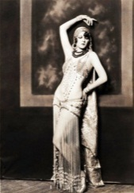**dry up:** shut up, get lost

**ducky:** very good

E

**earful:** enough

**edge:** intoxication, a buzz. i.e. "I've got an edge."

**Edisoned:** questioned

**egg:** a person who lives the big life

**embalmer:** a bootlegger

F

**Father Time:** any man over 30

**fella:** fellow. As common in its day as "man," "dude," or "guy" is today. "That John sure is a swell fella."

**fire extinguisher:** a chaperone

**fish:** (1) a college freshman (2) a first timer in prison

**flapper**: the modern woman of the 1920s.

**flat tire:** a bore

**flour lover:** a girl with too much face powder

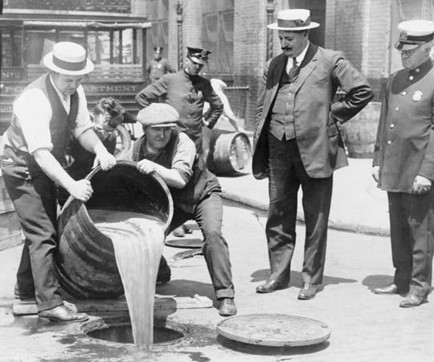**fly boy:** a glamorous term for an aviator

**four-flusher:** a person who feigns wealth while mooching off others.

**Frame:** To give false evidence , to set up someone

G

**gams:** legs

**gatecrasher:** see "crasher"

**get-up:** an outfit.

**giggle water:** booze

**glad rags:** "going out on the town" clothes

**gold-digger:** a woman who pursues men for their money.

**goofy:** in love

H

**hair of the dog:** a shot of alcohol.

**handcuff:** engagement ring

**hayburner:** (1) a gas guzzling car (2) a horse one loses money on

**high hat:** a snob, haughty, unapproachable

**hooch:** booze

**hood:** hoodlum

**hooey:** nonsense.

**hoof:** to walk

I

**"I have to go see a man about a dog.":** "I've got to leave now," often meaning to go buy whiskey.

**icy mitt:** rejection

**insured:** engaged

**iron:** a motorcycle, among motorcycle enthusiasts

J

**Jake:** great, ie. "Everything's Jake."

**Jalopy:** a dumpy old car

**java:** coffee

**jeepers creepers:** exclamation

**jitney:** a car employed as a private bus. Fare was usually five-cents; also called a "nickel."

**joint:** establishment or club, usually selling alcohol

**juice joint:** a speakeasy

K

**kale:** money

**keen:** appealing

**killjoy:** a solemn person

**kisser:** mouth

**kneeduster:** skirt

**know one's onions:** to know one's business or what one is talking about

L

**lay off:** cut the nonsense

**left holding the bag:** (1) to be cheated out of one's fair share (2) to be blamed for something

**level with me:** be honest

**line:** a false story, as in "to feed one a line."

**live wire:** a lively person

**lollygagger:** an idle person

M

**mad money:** carfare home to be used by a flapper if she has a fight with her date.

**milquetoast:** a very timid person; from the comic book character Casper Milquetoast, a hen-pecked male.

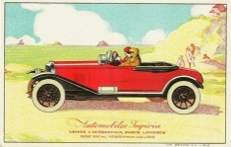**Moll:** A gangster's girl

**mooch:** to leave

**moonshine:** homemade whiskey

**mop:** a handkerchief

N

**neck:** to kiss passionately

**nifty:** great, excellent

**Nobody Home:** Describes some one who is dumb

**noodle juice:** tea

O

**Oliver Twist:** a skilled dancer

**on the lam:** fleeing from police

**on the level:** legitimate, honest

**on the up and up:** on the level

**orchid:** an expensive item

**owl:** a person who's out late

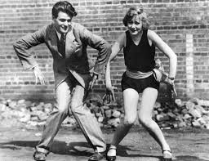P

**percolate:** (1) to boil over (2) As of 1925, to run smoothly; "perk"

**pet:** necking

**petting pantry:** movie theater

**piker:** (1) a cheapskate (2) a coward

**pill:** (1) a teacher (2) an unlikable person

**pinch:** to arrest. Pinched: to be arrested.

**pinko:** liberal

**pipe down:** stop talking

**prune pit:** anything that is old-fashioned

**punch the bag:** small talk

**Pushover:** A person easily convinced

**putting on the ritz:** after the Ritz Hotel - doing something in high style. Also "ritzy."

R

**rag-a-muffin:** a dirty or disheveled individual

**razz:** to make fun of

**Real McCoy:** a genuine item

**Ritzy:** Elegant (from the hotel)

**Rock of Ages:** a woman over the age of 30.

S

**sap:** a fool, an idiot. Very common term in the 20s.

**says you:** a reaction of disbelief

**Scram:** Ask someone to leave immediately

**screwy:** crazy; "You're screwy!"

**sheba:** one's girlfriend

**sheik:** one's boyfriend

**shiv:** a knife

**sitting pretty:** in a prime position

**skirt:** an attractive female

**smarty:** a cute flapper

**snake charmer:** a woman involved in bootlegging

**speakeasy:** a bar selling illegal liquor

**Spiffy:** An elegant appearance

**spill:** to talk

**squirrel:** to hide

**streeted:** thrown out of a party

**stuck on:** having a crush on; in love.

**sugar daddy:** older boyfriend who showers girlfriend with gifts

**swanky:** (1) good (2) elegant

**swell:** (1) good (2) a high class person

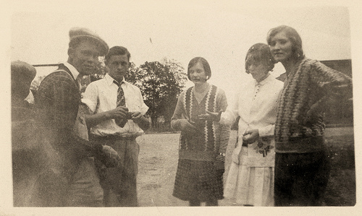T

**take someone for a ride:** to take someone to a deserted location and murder them.

**tasty:** appealing

**teenager**: not a common term until 1930; before then, the term was "young adults."

**ten cent box**: a taxi cab

**tell it to Sweeney:** tell it to someone who'll believe it.

**tight:** attractive

**Tin Pan Alley:** the music industry in New York, located between 48th and 52nd Streets

**tomato:** a female

**torpedo:** a hired thug or hitman

U

**unreal:** special

**upchuck:** to vomit

**upstage:** snobby

V

**vamp**: a seducer of men, an aggressive flirt

W

**water-proof:** a face that doesn't require make-up

**weasel:** a young man who steals a girl from her boyfriend

**wet blanket**: see Killjoy

**What's eating you?:** What's wrong?

**whoopee:** wild fun

**windsucker:** a braggart

**Woof! Woof!:** ridicule

Y **You slay me!:** That's funny!