[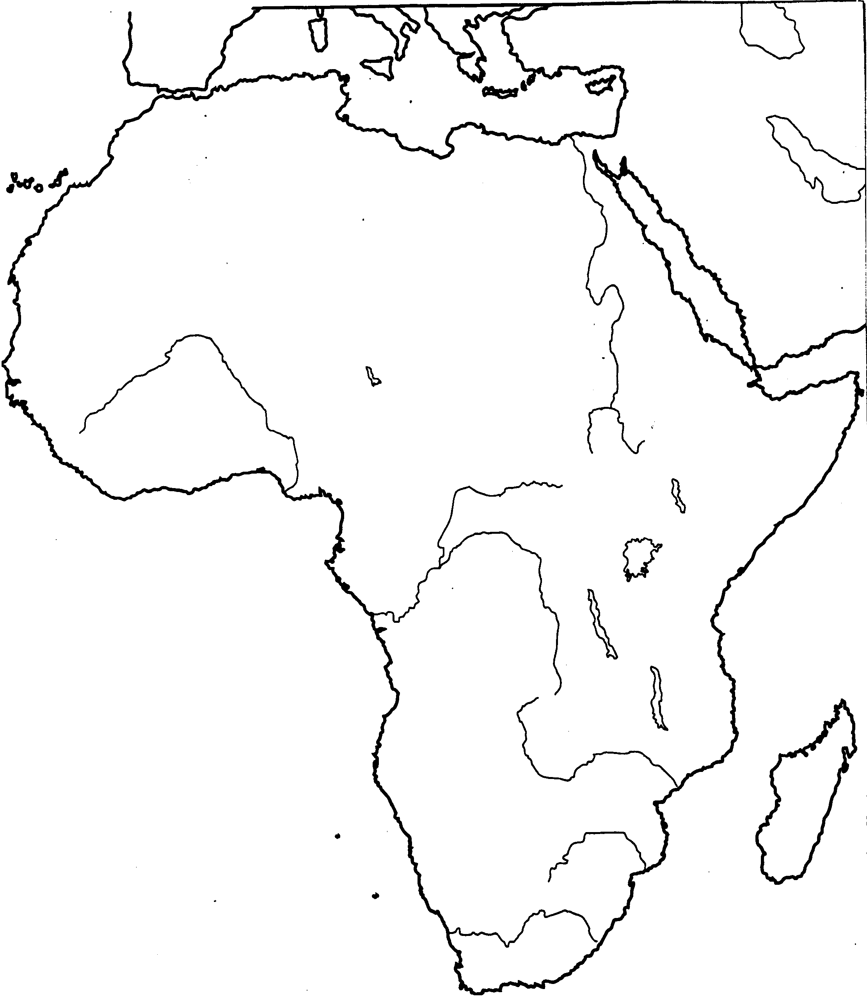](http://www.lcsc.edu/elmartin/Maps/Africa%20Blank.bmp)