Name (A/B): _________________________
Date: _____
Promises Notes
Directions: As you watch the film, please take notes on the following-must have information from EVERY DAY we watch
Daniel and Yarko | 1 Fact about Daniel and Yarko:
Nationality |  | Religion
Quotes (2-3) that show their views on the conflict

Mahmoud | 1 Fact about Mahmoud:
Nationality |  | Religion
Quotes (3+) that show their views on the conflict

Shlomo | 1 Fact about Shlomo:
Nationality |  | Religion | 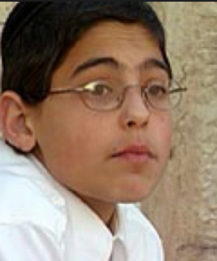
Quotes (3+) that show their views on the conflict

Sanabel | 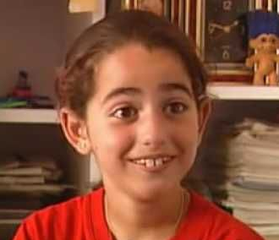  1 Fact about Sanabel:
Nationality |  | Religion
Quotes (3+) that show their views on the conflict

Faraj | 1 Fact about Faraj:
 | Nationality: |  | Religion | 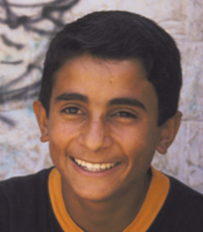
Quotes (3+) that show their views on the conflict
Moishe | 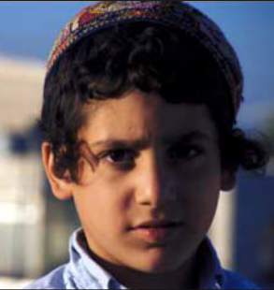  1 Fact about Moishe:
Nationality: |  | Religion:
Quotes (3+) that show their views on the conflict

Directions: AFTER the film is over, answer the following questions – INCLUDE INFORMATION FROM ALL PARTS of the film, not just one day.
1. Write down three facts about life in Israel/Palestine:

2. Name three (3) things that these kids have in common.

3. How is life different for Palestinian young people than Israeli young people? Use specific examples from the movie and different information than what you wrote for answers in the first 2 questions.

4. Which character changes the most over the course of the film? How does he/she change?

5. After watching the film, what do you think are the major barriers to peace in the Middle East?

