**Name:**

**Mainstream Americans**

*Fill in examples for each section that describe the mainstream attitude on the topic. Should have multiple examples for each. May use class notes and chapter 49 of your book.*

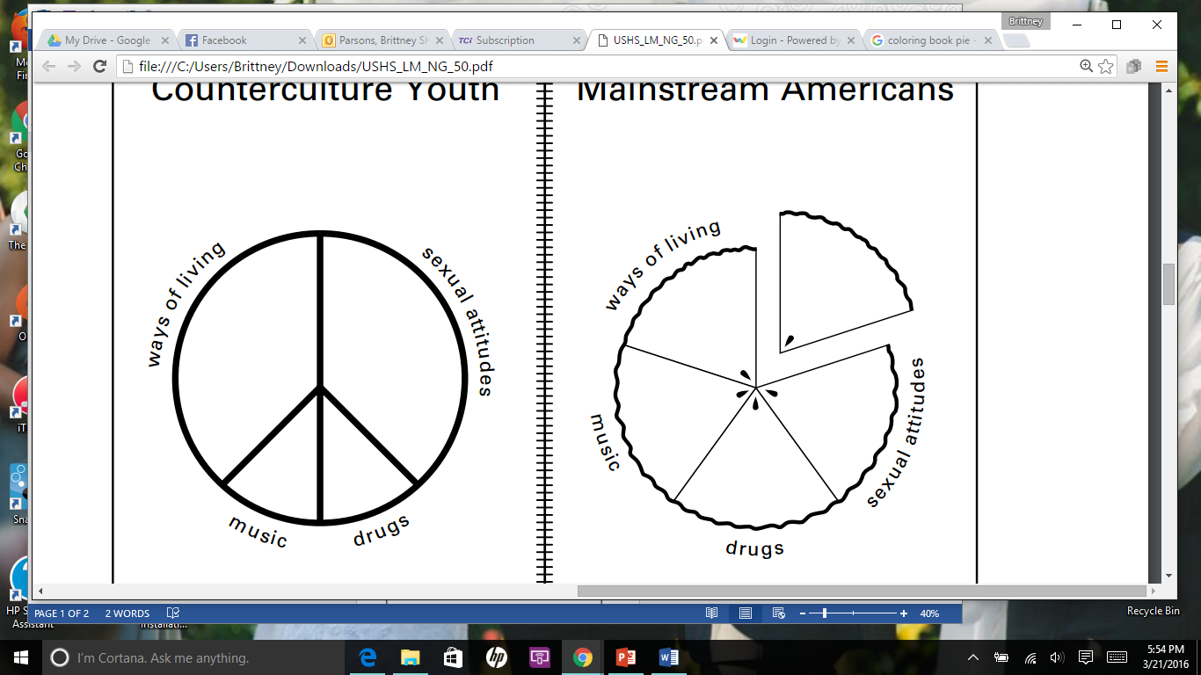

*Write one sentence describing how the symbol represents Mainstream America:*

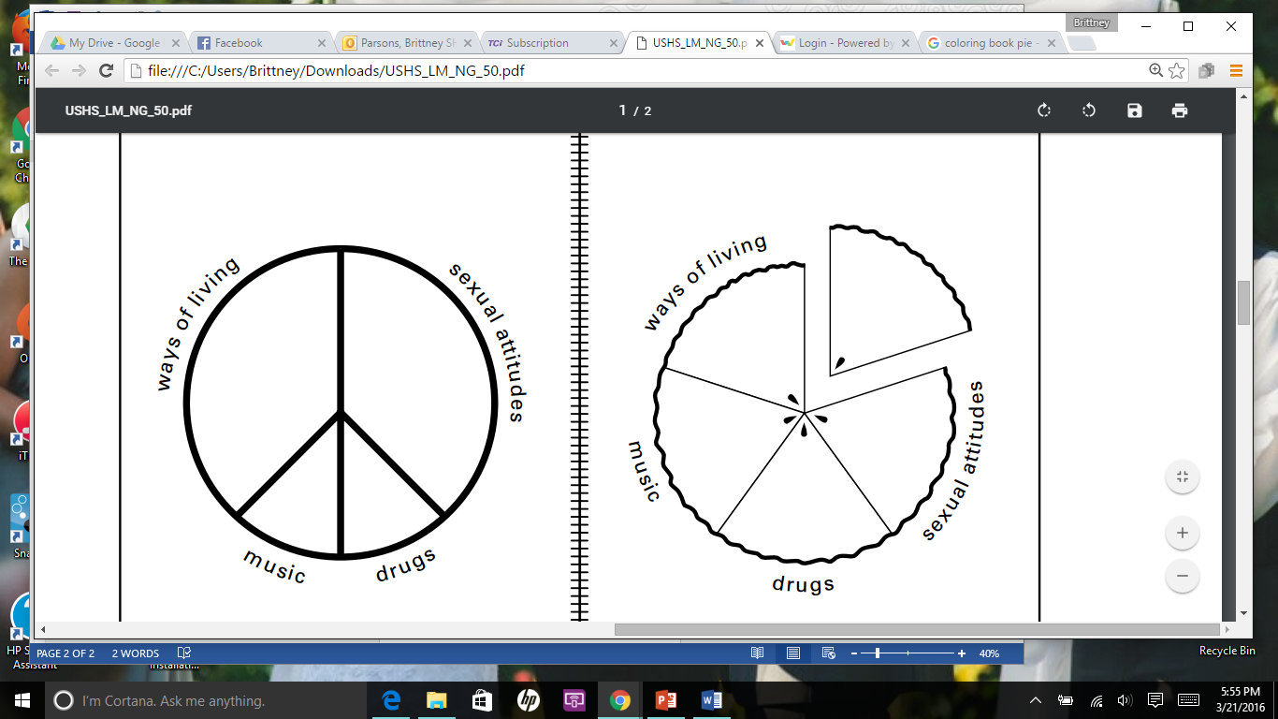

*Fill in examples for each section that describe the counterculture attitude on the topic. Should have multiple examples for each. May use class notes and chapter 49 of your book.*

**Counterculture Youth**

*Write one sentence describing how the symbol represents Counterculture Youth:*