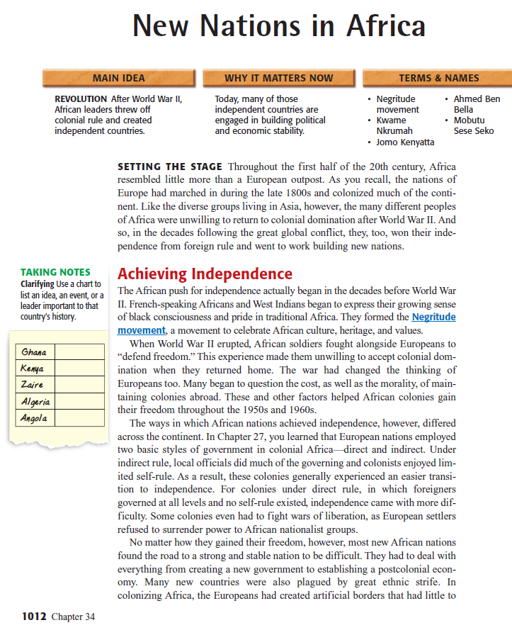
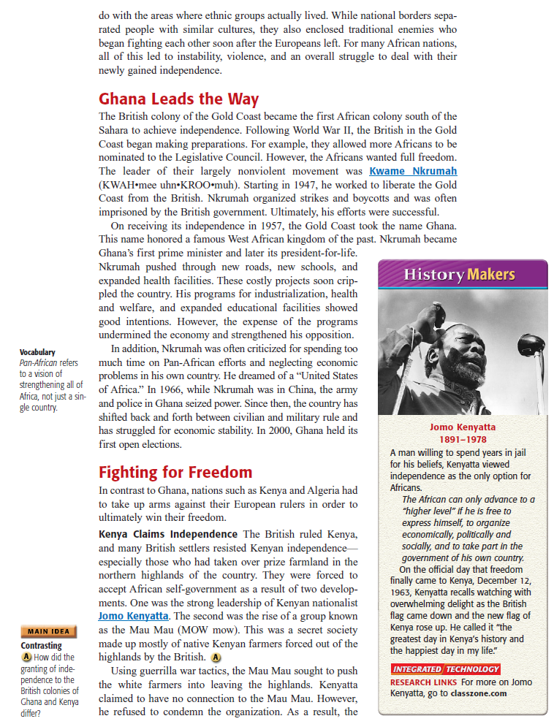
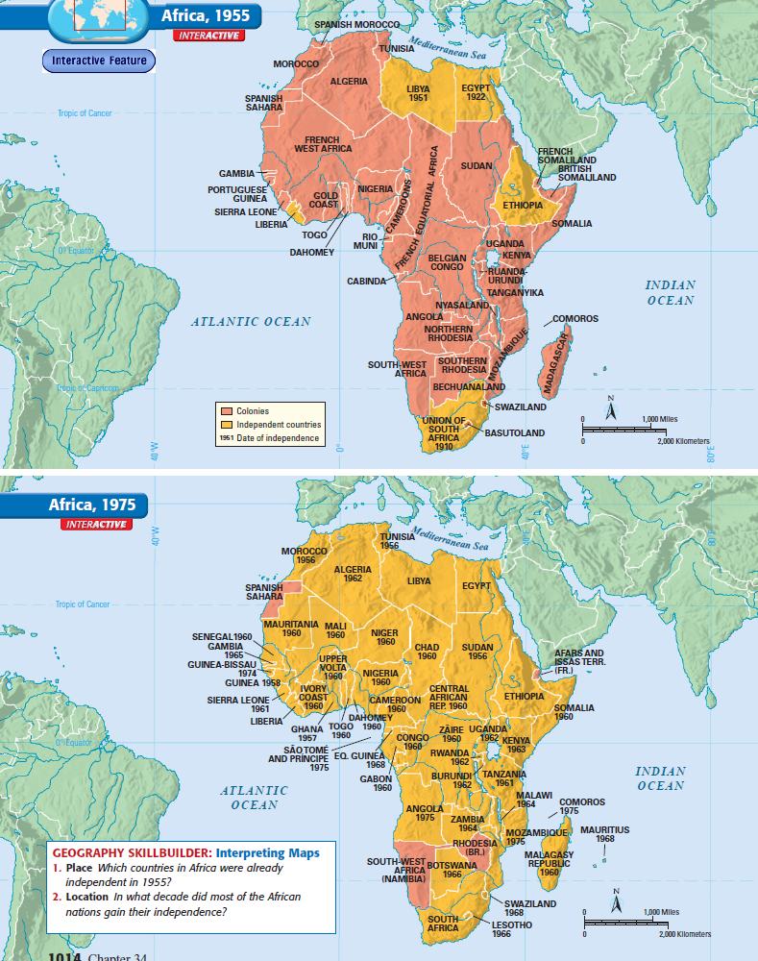
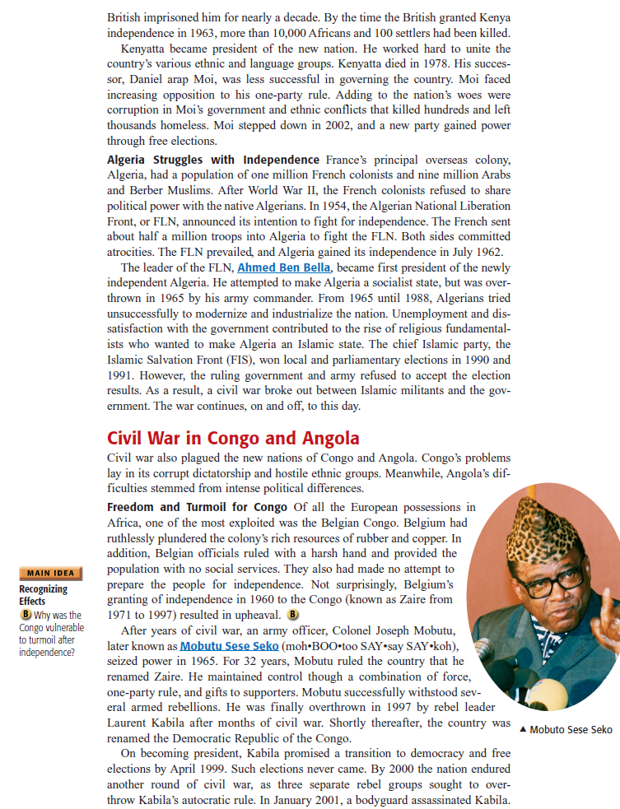
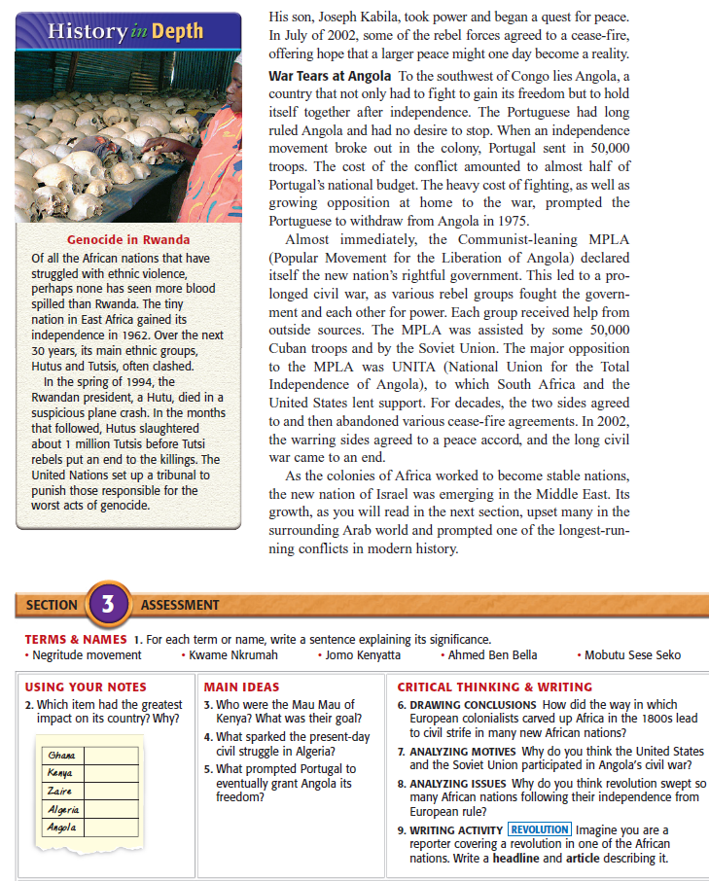Citation:
Beck, Roger B., Black, Linda, Krieger, Larry S., Naylor, Phillip C.Shabaka, Dahia Ibo, eds. World History: Patterns Of
Interaction. Evanston, Ill. : McDougal Littell, 2007. Print.

